Stud ent Name | Charles Meredith
Activity Type | Session Hijacking and Evading Firewalls and IDS-Lab

Instructions
Perform the labs per the instructions in the iLabs environment.
- As you complete the tasks in the lab, insert a screenshot of the steps indicated below.
- Screenshots should contain unique information generated within the VM; this should include a shell (Bash in Linux, or PowerShell in Windows) with the output of the date command and your username typed below.
- Perform all the tasks shown below. Only provide screenshots for the tasks that specify a screenshot.

Tasks and Screenshots
Complete the following lab tasks in the Session Hijacking iLab Module:
- Lab 1 – Perform Session Hijacking
  - Task 1 – Hijack a Session using Caido
    - Screenshot step 38.

  - Task 2 – Intercept HTTP Traffic using Hetty
    - Screenshot step 25.
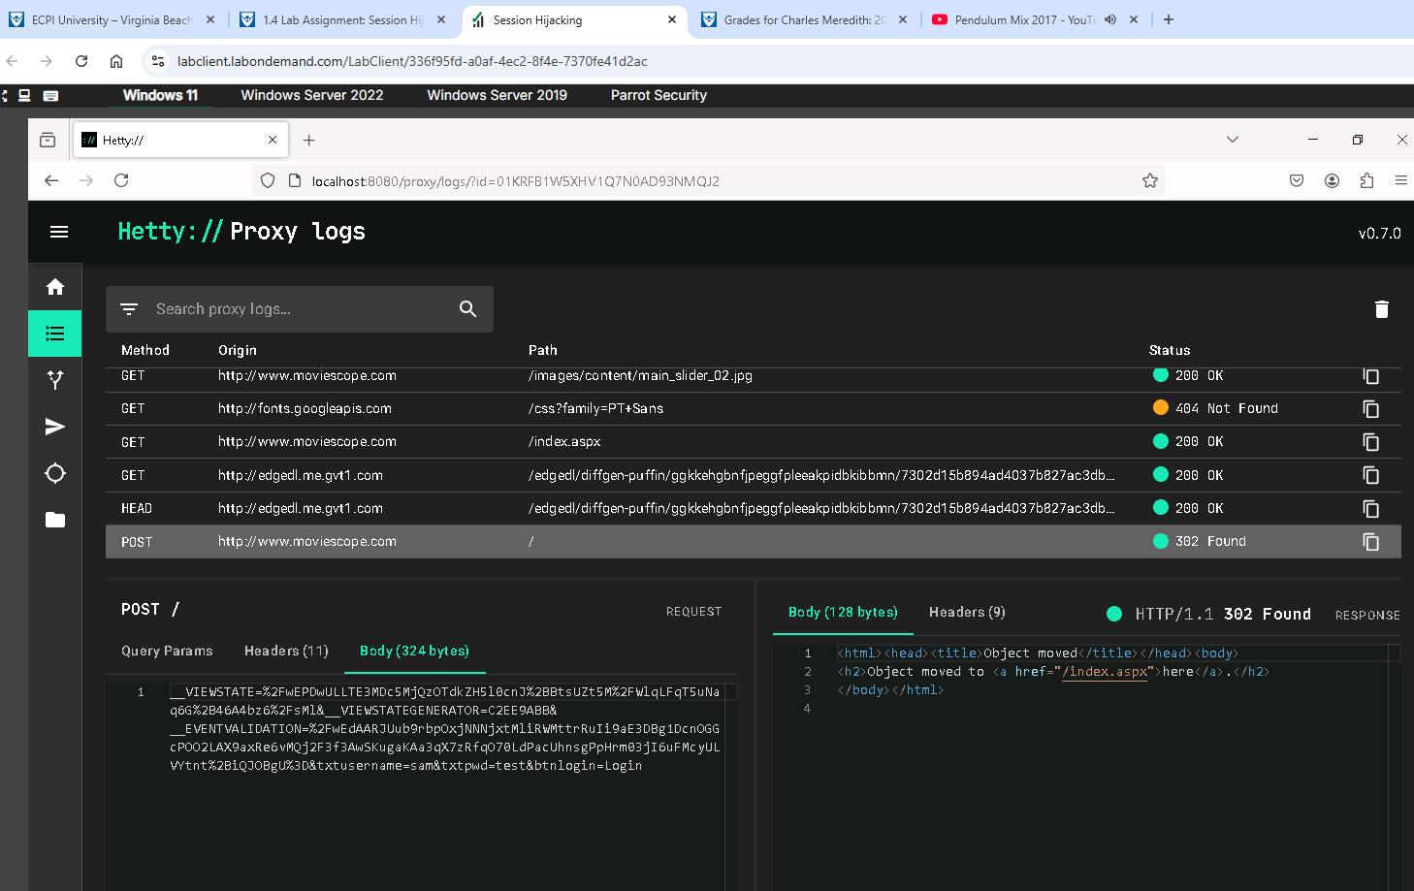
- Lab 2 – Detect Session Hijacking
  - Task 1 – Detect Session Hijacking using Wireshark
    - Screenshot step 11.
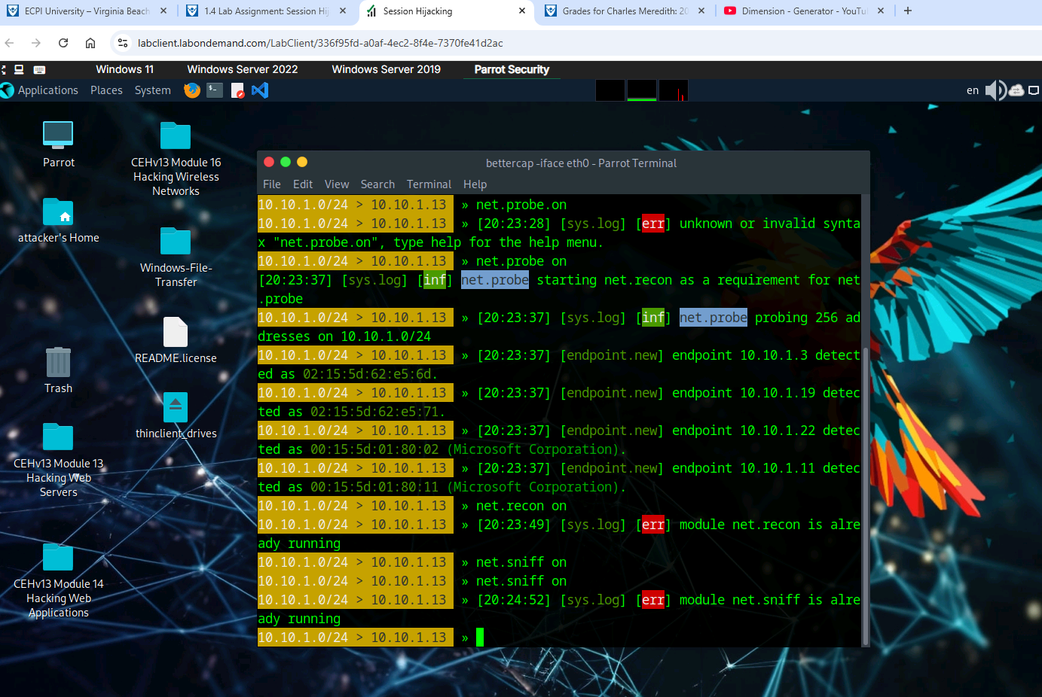
    - Screenshot step 12.
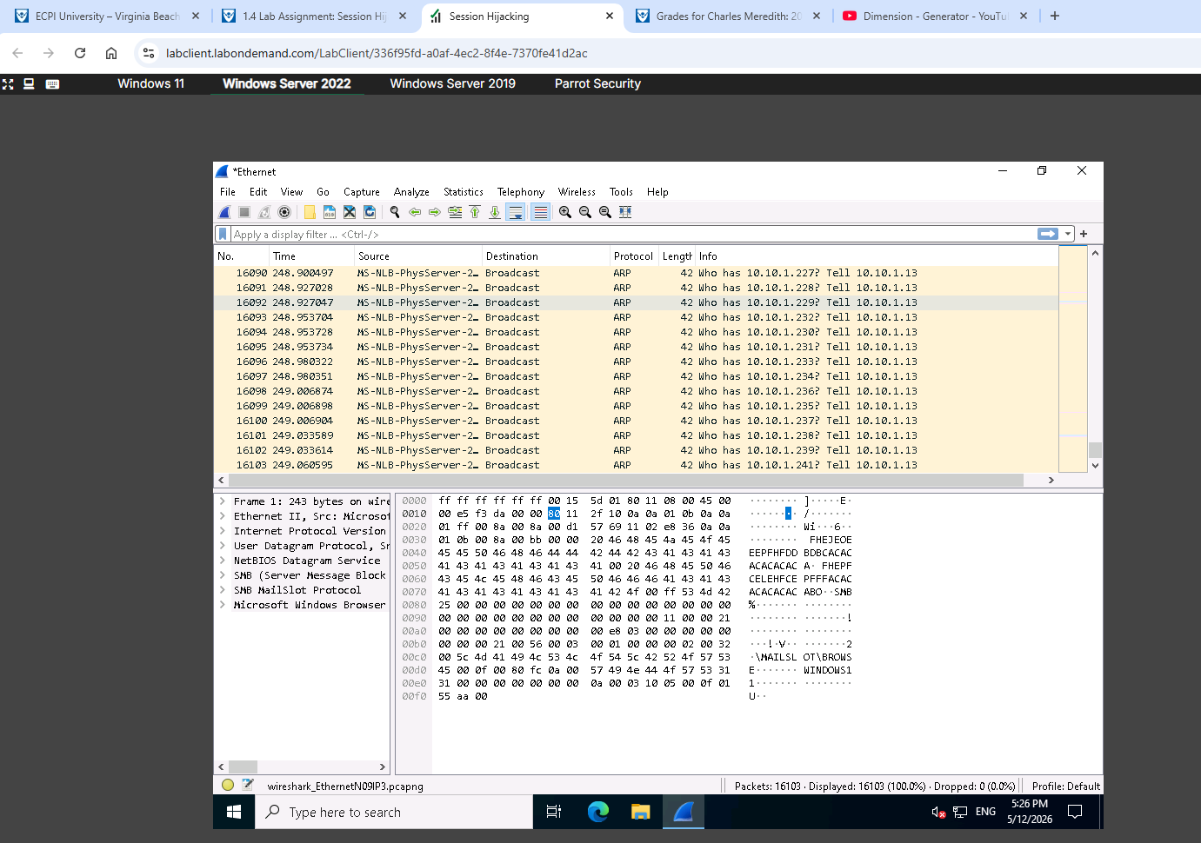
  - Task 1 – Detect Session Hijacking using Wireshark
    - Screenshot step 16.

Complete the following lab tasks in the Evading IDS and Firewalls iLab Module:

- Lab 1 - Perform Intrusion Detection using Various Tools
  - Task 1 – Detect Intrusions using Snort
1. Screenshot step 68.
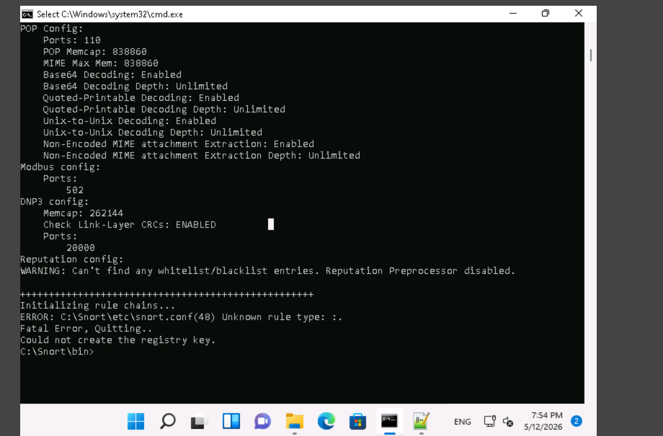
  - Task 2 – Deploy Cowrie Honeypot to Detect Malicious Network Traffic
- Screenshot 25.
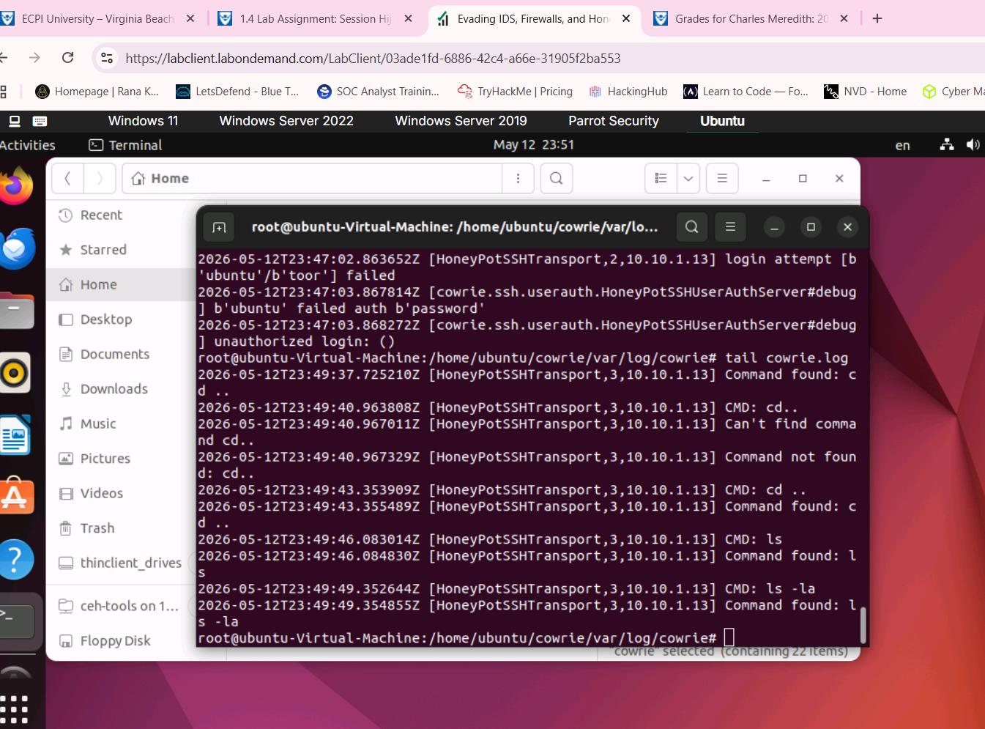
- Lab 2 – Evade Firewalls using Various Evasion Techniques
  - Task 1 – Evade Firewall the Windows BITSAdmin
1. Screenshot step 14
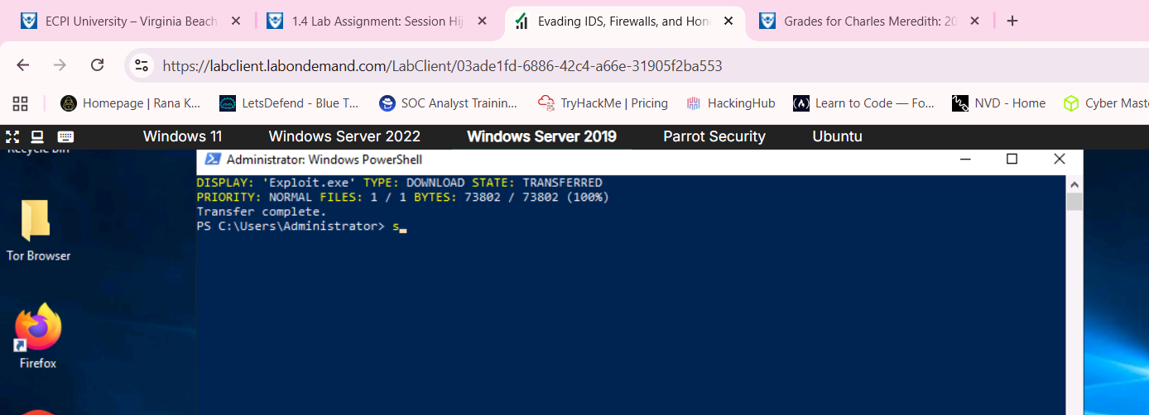
2. Screenshot step 15
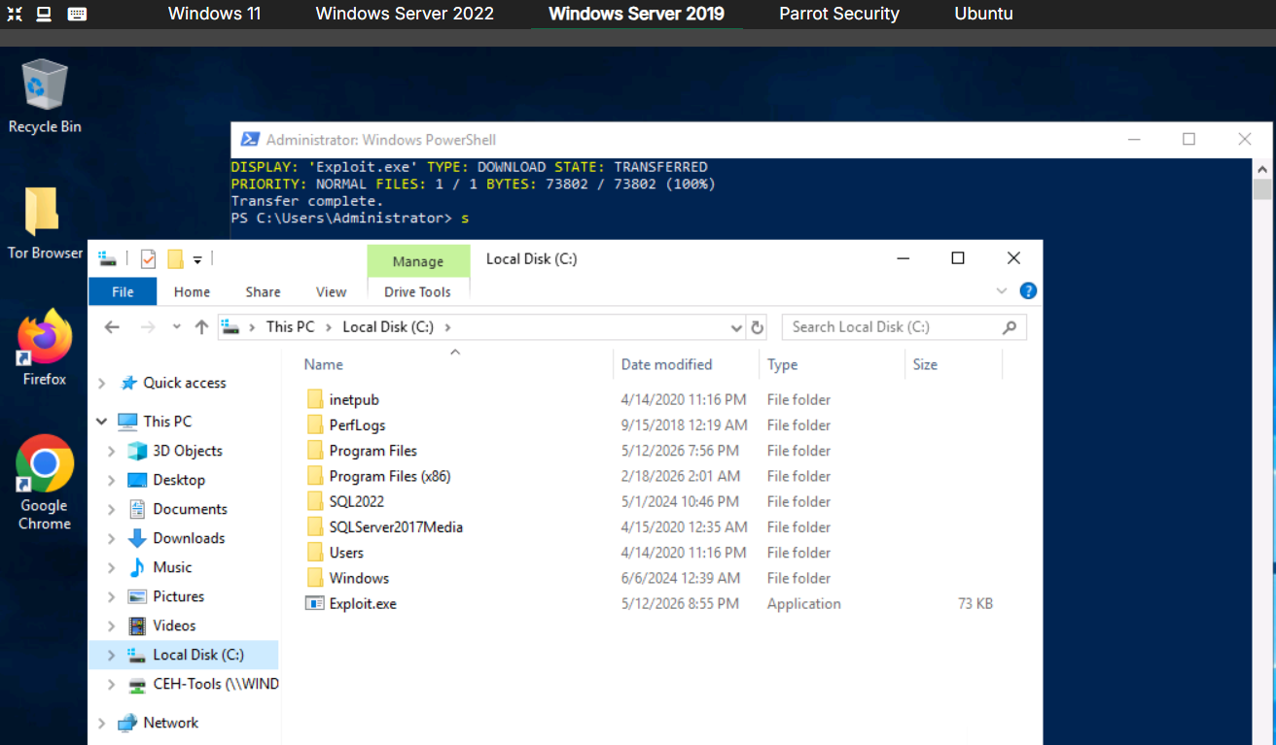

Summary
Write a few paragraphs summarizing the key skills you have acquired during this lab.
In this lab we ascertained many a new skills. For example, we use different session hijacking techniques/applications such as Caido or Hetty. These programs allowed for MITM attacks, create and edit requests and the ability to replay proxy requests in real-time. We also used Wireshark to capture live traffic to figure out user credentials. We created a honey pot using Cowrie, nmap to check for open points and used server message block protocol to execute a reverse_tcp executable on the target machine. Ultimately, the lab was very informative but a little tedious in nature when it comes to configuring Snort.

Review Questions
Answer the following questions.
1. Attackers can use Session Hijacking to launch various kinds of attacks such as man-in-the-middle (MITM) and Denial-of-Service (DoS) attacks.
2. Caido offers exploration tools, including sitemap, history, and intercept features, which aid in identifying vulnerabilities and analyzing requests in real-time.
3. Hetty can be used to perform Machine-in-the-middle (MITM) attack, manually create/edit requests, and replay proxied requests for HTTP clients and further intercept requests and responses for manual review.
4. Wireshark captures live network traffic from Ethernet, IEEE 802.11, PPP/HDLC, ATM, Bluetooth, USB, Token Ring, Frame Relay, and FDDI networks.
5. The goal of the Reconnaissance Phase is to find possible attacks against a network.
6. Snort is an open-source network intrusion detection system, capable of performing real-time traffic analysis and packet logging on IP networks.
7. Cowrie serves as an SSH and Telnet honeypot, capable of capturing brute-force attacks and the actions taken by attackers within the shell.
8. Nmap has numerous features that were created specifically to bypass these protections. It can issue a mapping of a system framework, through which you can view a substantial amount of information, from OS renditions to open ports.
9. cURL is used by system administrators and programmers for downloading files from or uploading files to HTTP webservers and SMB file shares.

